Note: There is no need to pair the phone with VP3600. Because the Bluetooth list of iphone won’t display the Bluetooth name of VP3600. You should just turn iphone’s Bluetooth on and VP3600.

- Power on the VP3600.
- Change the password to something else besides 123456.

2.1）Set Bluetooth parameters (77-81)
This command may be used to set Bluetooth name and password.
Command data field
Data field | Length (bytes) | Description
Name | Var to 26 | Ascii, must end with 0x00
Old password | 6 | Hex
New password | 6 | Hex
- Open your iPhone device’s settings app.
- Turn Bluetooth on. (it will be off in airplane mode.)
- Open the demo NEO 2 app.
- Enter the VP3600's Bluetooth name in the blank (see below, higher right) and press “Start BLE Scan” button (see below, higher left):
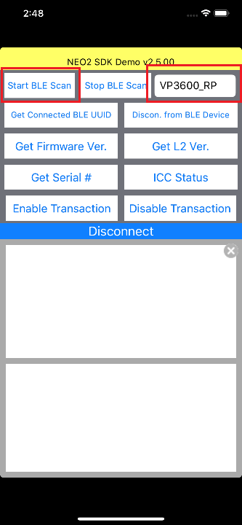
- Input the Password, then press the “Pair” button to pair the device. (See illustration below.) The “Disconnected” will become “Connected” if reader is successfully connected and you can see the bluetooth icon shows in VP3600. Then you can send commands and get responses.

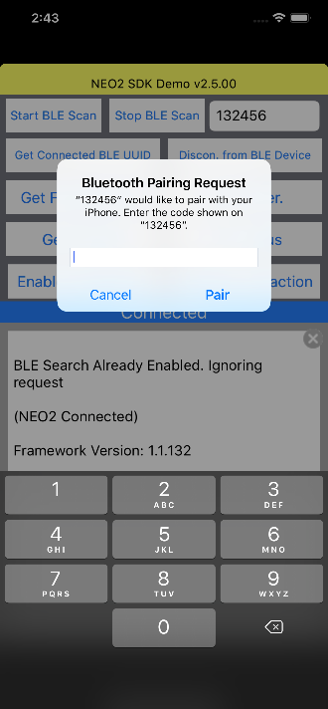
- Press “Get Firmware Ver.” Button.
- Firmware version data will appear in the window.
