How to Pair the VP3600 using BLE (Bluetooth Low Energy)
- Go to Bluetooth setting and forget the device.
- Power on the VP3600.
- Change the password to something else besides 123456.

  - Set Bluetooth parameters (77-81)
This command may be used to set Bluetooth name and password.
Command Frame
Byte 0-9 | Byte 10 | Byte 11 |  | Byte 12 | Byte 13 | Byte 14 | Byte 14+n | Byte 15+n
Header Tag & Protocol Version | Command | Sub-Command |  | Data Length (MSB) | Data Length (LSB) | Data | CRC (LSB) | CRC (MSB)
ViVOtech2\0 | 77h | 81h |  | var |  | var
Command data field
Data field | Length (bytes) | Description
Name | Var to 26 | Ascii, must end with 0x00
Old password | 6 | Hex
New password | 6 | Hex
- Open your android device’s settings app.
- Turn Bluetooth on. (it will be off in airplane mode.)
- Select the VP3600's Bluetooth name from the list of available devices.
- Input the Password, then “OK” to pair the device. (See illustration below.)
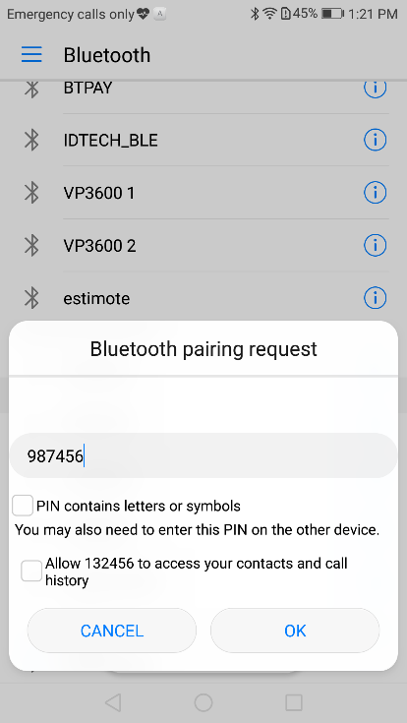

2. Using the Demo App
If you have not already done so, please install the ID TECH Android SDK demo app first.
- Open the demo app and select NEO 2 (Bluetooth):
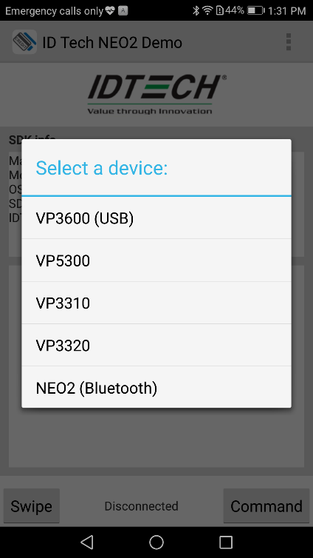
- Enter the VP3600's Bluetooth name, accept it (with Okay):
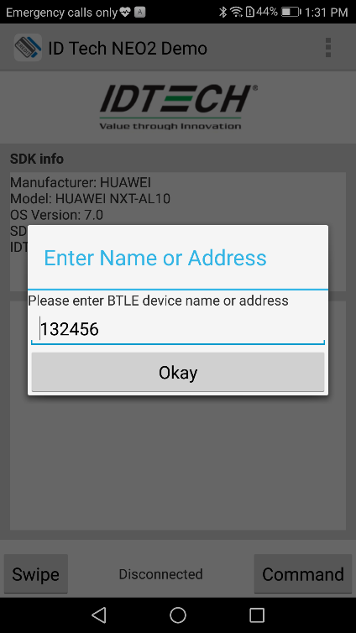
- The “Disconnected” will become “Connected”(see below, lower center) if reader is successfully connected and you can see the bluetooth icon shows in VP3600. Then you can send commands and get responses.

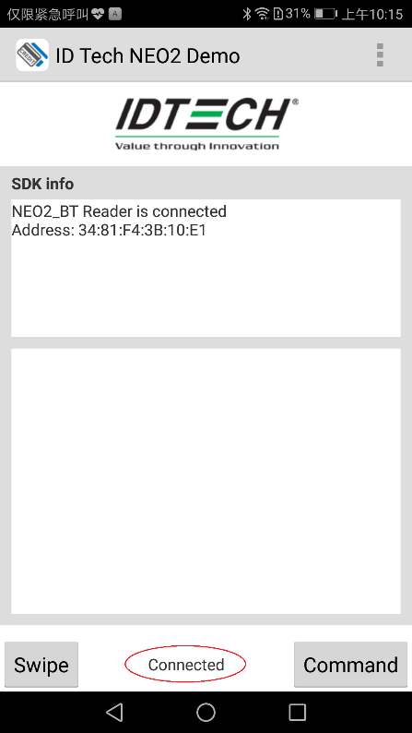
- Press Swipe/Tap button (see below, lower left).
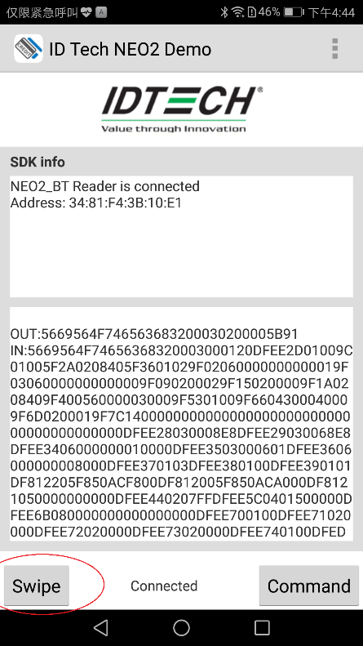
- When prompted, swipe or tap a card. (See below.)
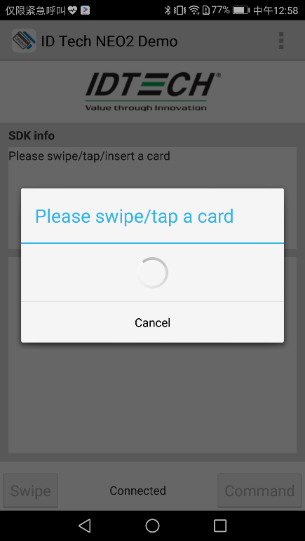
- Card data will appear in the window.
