Google SmartTap Terminal Specification

NEO3.x Platform

Rev. 51

Introduction

General
The purpose of this document is to introduce ID TECH NEO3.x family products which supports Google SmartTap 2.1. It also introduce the technical design of Google SmartTap.

- Introduction of NEO3.x family products
- Technical design of Google SmartTap 2.1.

NEO3.x Family Products
ID TECH NEO3.x as a new generation of platform is designed for payment terminals. NEO3 family products shared the same MPU and code database. The NEO3 platform uses NuttX 10.2.0 as operating system. The NEO3 family products can process different kinds of brands cards. For example, MasterCard, VISA, Discover,Amex Expresspay, JCB, CUP,Interac,etc. It also can supports mobile wallet, like SmartTap and AppleVAS.

The NEO3.x family products includes Kiosk V, VP3350,VP7200,VP6825,VP8810,VP8810P and AP6800.

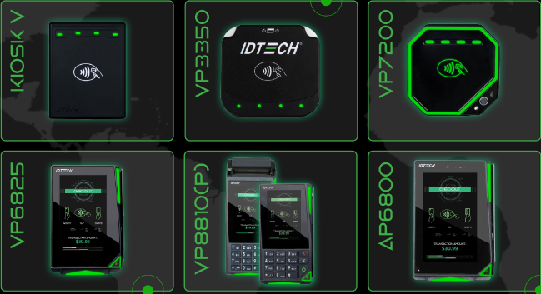
NEO3.x Family Products

Hardware Model Number
Product Name | Model Number
Kiosk V | IDVK-5xxx
VP3350 | IDMR-Sxx93x  IDMR-Nxx93x
VP7200 | ID72-xxxx  ID72N-xxxx
VP6825 | VP6825-xxxx
VP8810/VP8810P | VP8810-xxxx
AP6800 | AP6800-x3xxx  AP6800-x1xxx
Model Number of NEO3 Products
Note: “x” is wildcard.

Firmware Version
Following firmwares supports Google SmartTap 2.1
- FW v1.00.xxx.xxxx.S
- FW v2.00.xxx.xxxx
Note: “x” is wildcard.

Application Version
SmartTap 2.1, v1.2

Operating System
The operating system of NEO3.0 platform uses NuttX 10.2.0

EMV Certification

The products get approval from PCI SSC, EMV, MasterCard,VISA, Discover, AmexExpressPay, Interac, JCB,CUP,etc. For more information, please access ID tech portal: Homepage - ID TECH Products.

Technical documentation

Configure the Colletor ID and other SmartTap settings
Use IDTECH’s USDK Demo to load Colletor ID, other SmartTap settings, including private key and key version, Receive the transaction result. USDK Demo can be downloaded from our company website.

