How to configure the card reader with a configure file provided by your support team?
A:
The data output format of an IDTECH’s MM2, MiniMagDuo, OmniDuo, SecureMag and the MSR built in the VersaKey can be configured to the format expected by the POS application software. Often times, user is given a .cfs2 type configure file by our tech support team. Once you have it, please follow the instruction below to get the card reader configured and tested:
1. Downloaded and installed MagSwipe Configuration Software on a PC
2. Launch the above mentioned software utility with the card reader or the POS keyboard connected to the PC
3. Click the Change Advanced Reader Settings button on the left side
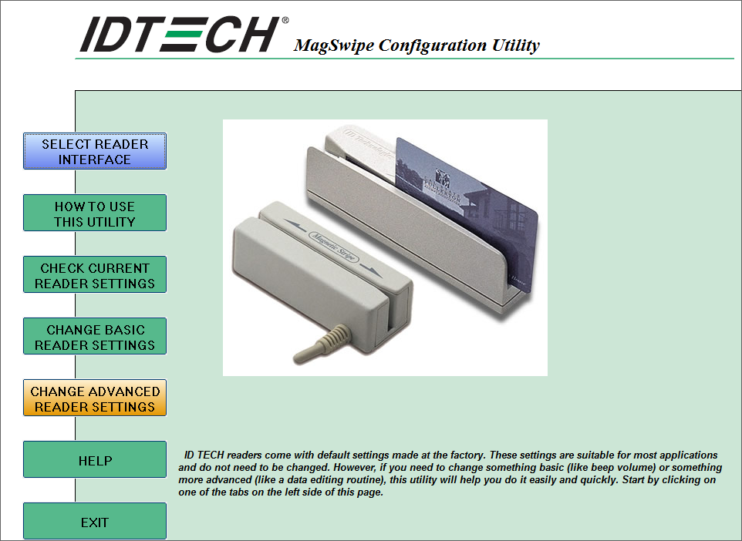
4. Click the Load From File button on the bottom
5. Browser over to the location where the configure file was saved and select the file and click the Open button to have it loaded into the software utility
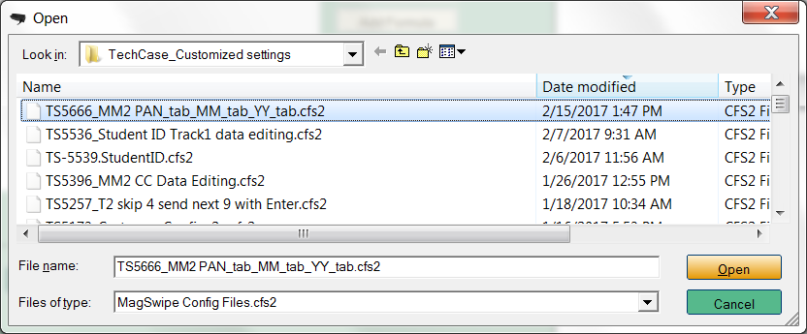
6. Click the Send to MSR button to have it send to the card reader and click OK button with success pop up
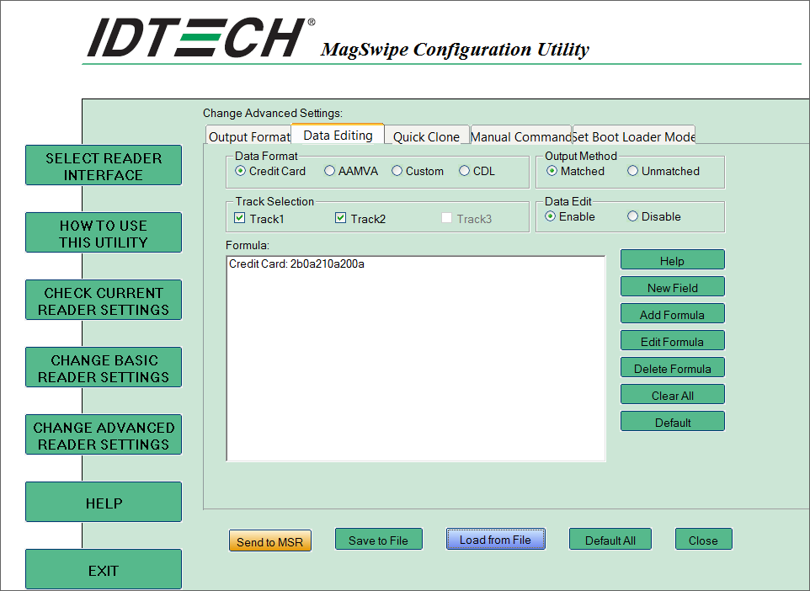
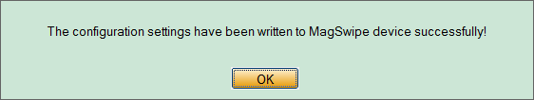
7. Test read the card in Notepad (if USB Keyboard interface reader) to confirm the expected output
8. Try using it in your own POS app to confirm it works as expected
Note:
If you the configure file is given from our support portal, you do need to create a user name and password to log into our Tech Support Portal to fetch the file.

